Basic docker
- Login with docker hub to docker desktop

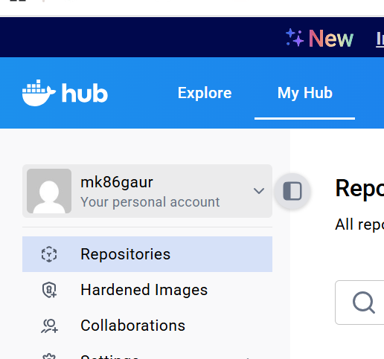docker hub account :- mk86gaur pws :- Qss@2024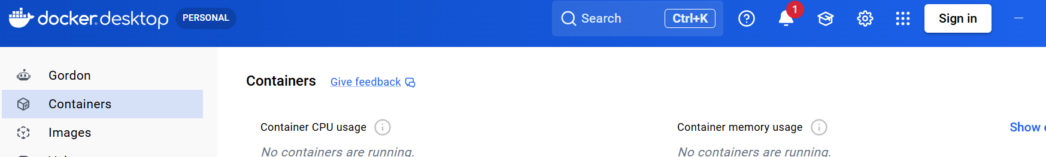

- Taking Flash code
- Python 2. Library --- pip install, 3. Sorce code, 4. Python – app.py
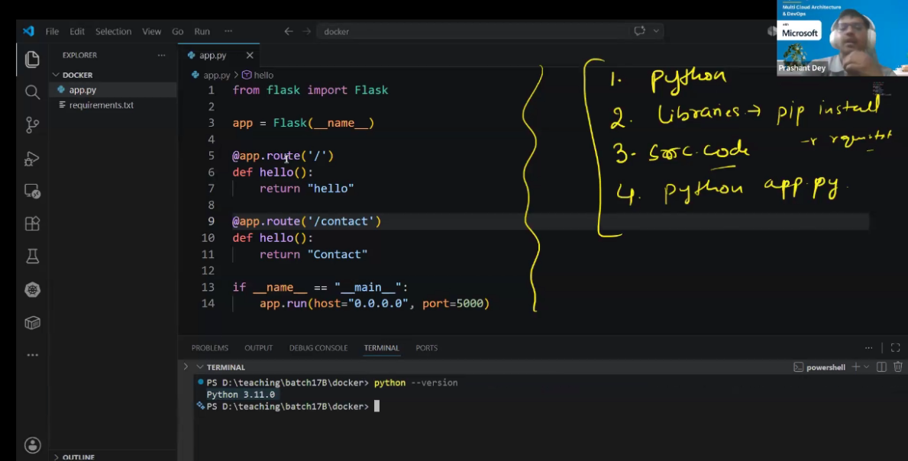

Flask code (source code)
- from flask import Flask

- app = Flask(__name__)

- @app.route('/')
- def hello():
- return "Hello Manoj"

- @app.route('/contact')
- def contact():
- return "Contact"

- if __name__ == "__main__":
- app.run(host="0.0.0.0", port=5000)

- Python –version
- pip install -r .\requirements.txt
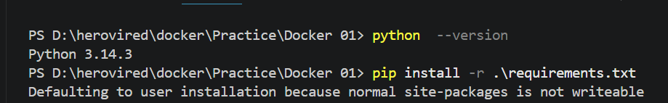
- 4. Run python code (run sourcecode) python app.py
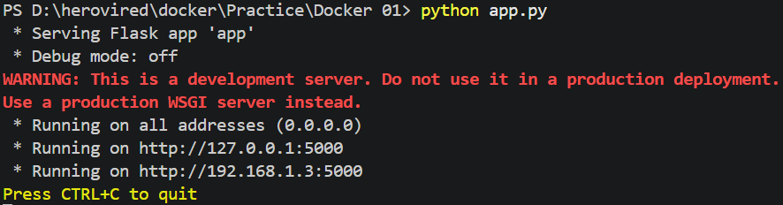
Check
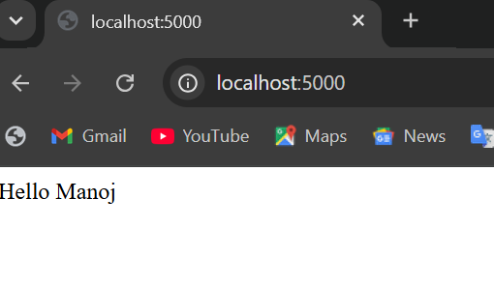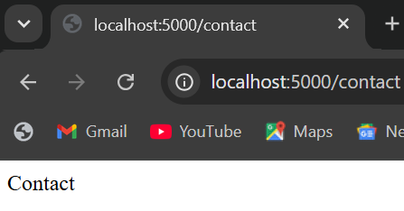
- Create Dockerfile file 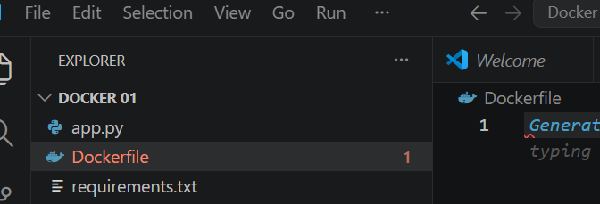
7. executing command of application
6. Runing port ( expose port no.)
5.Copy source code file
4. run command
3. Copy for requirement (requirements.txt)
2. Directory (working directory of aap)
- Python
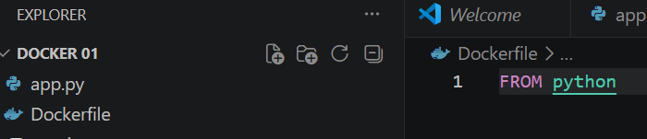 layering of base program ( FROM python:version)
Note :- use alpine version of program
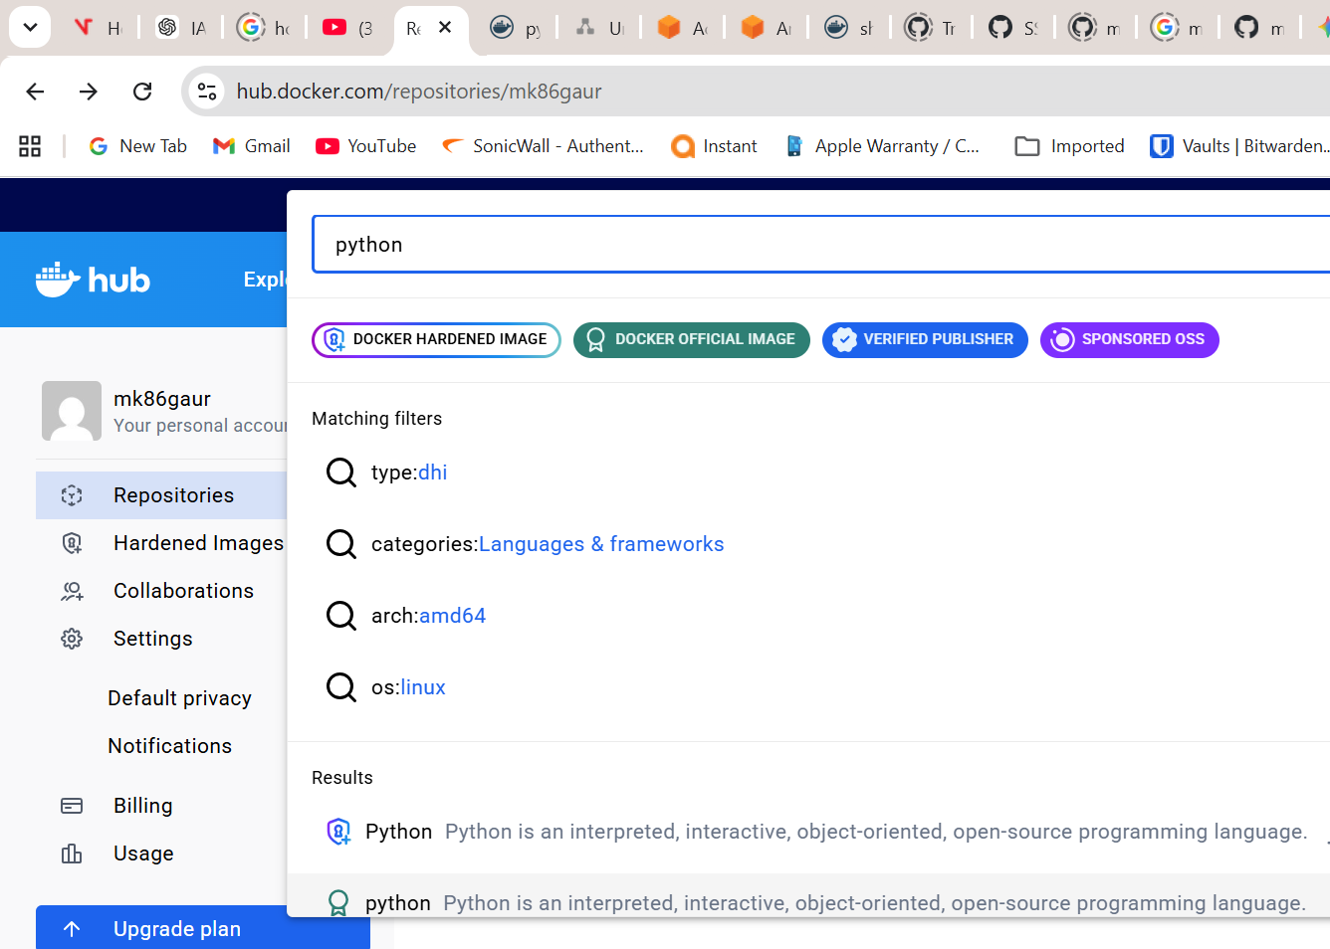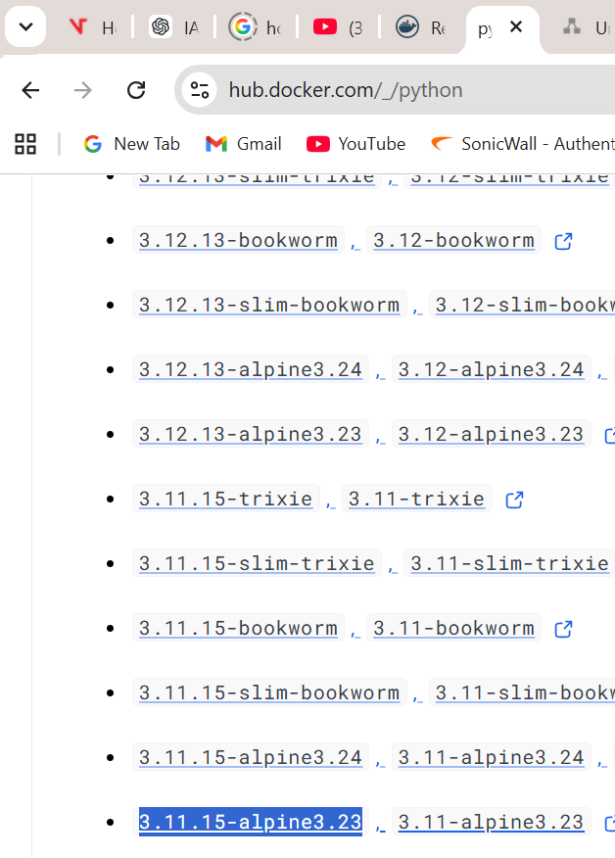
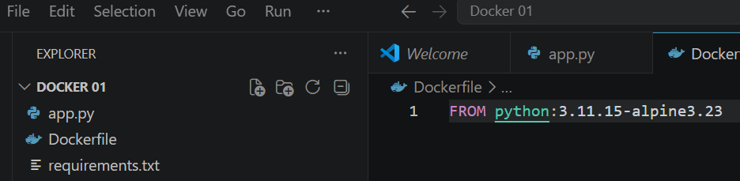
Mention working directory
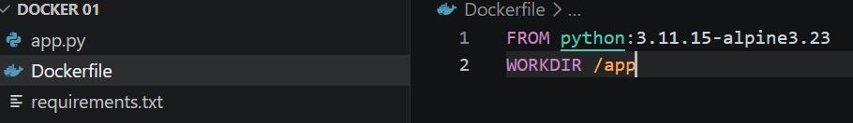
Copying requiremen with current and working directory (.)
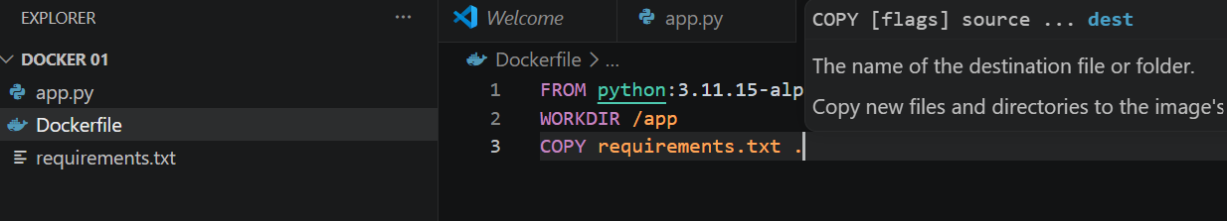

Run command
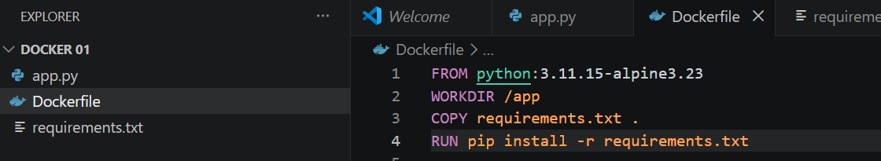
Copy to source code file with total path (. .)
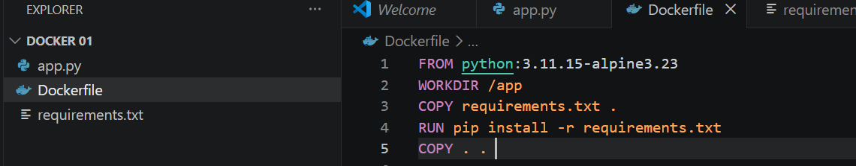
Runing Expose port of application
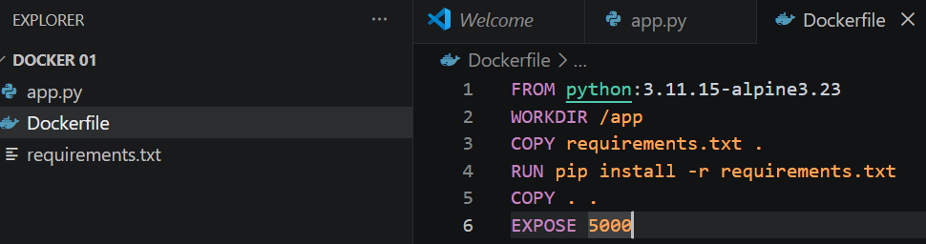
Run executing command of the application
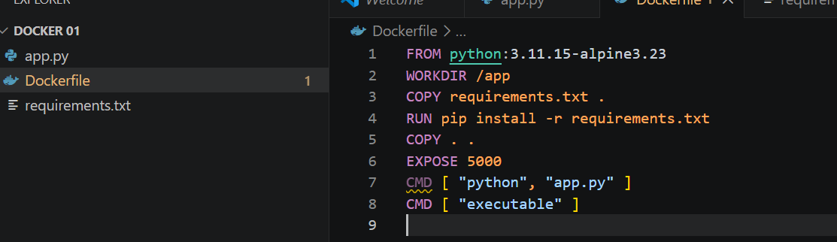
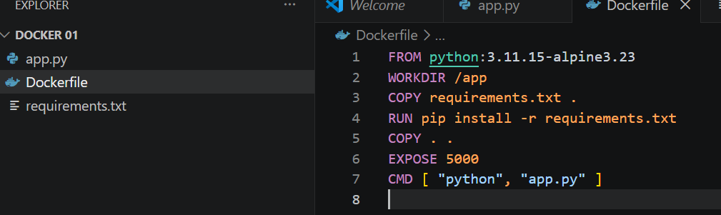
Now build the docker image
Command :- docker build . -t demodockerapp:v1.0
Expiation of command - docker build - run build of image , “. “ file name or use (Dockerfile) ,
demodockerapp :--- image name , :v1.0 :--- image version
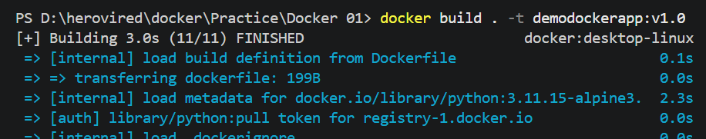
Show the Images
Command :- docker image ( image call when image not use and container calling when image is running )
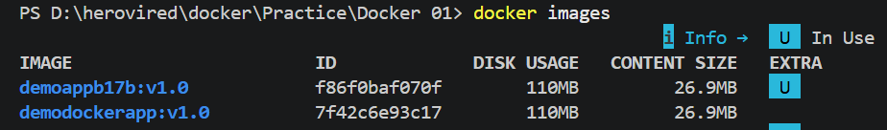
Run the image
Command :- docker run –p 5001:5000 demodockerapp:v1.0
docker run :-- run the image , -p :- to run port of image 5001 is windows port :5000 is container running port demodockerapp:v1.0 image name
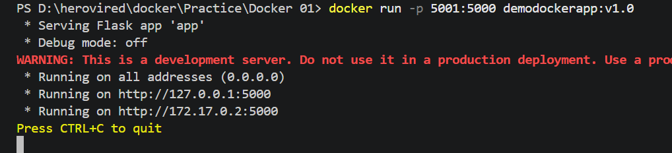
Check

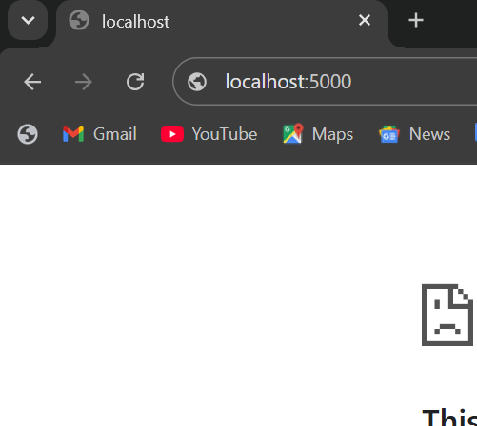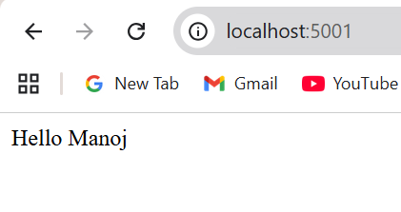
Can we change the port
Check
Not running on 5001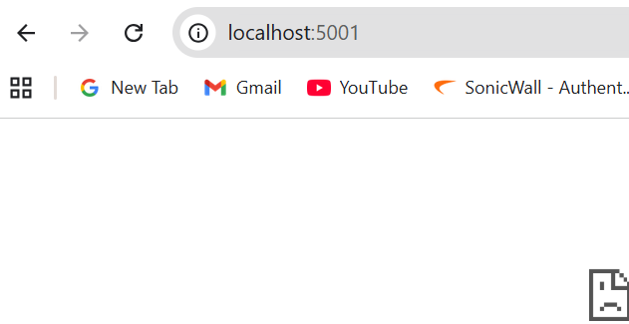 running on 5005 
To run the container on background
Command :- docker run -d -p 5005:5000 demodockerapp:v1.0
-d is to used for run the container on background
To show the list of running container
Command :- docker ps
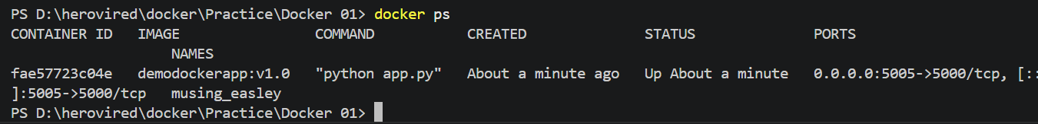
To stop the running container
Command :- docker stop <container id or container name >
Check


To push the local Docker desktop image to Docker hub repository
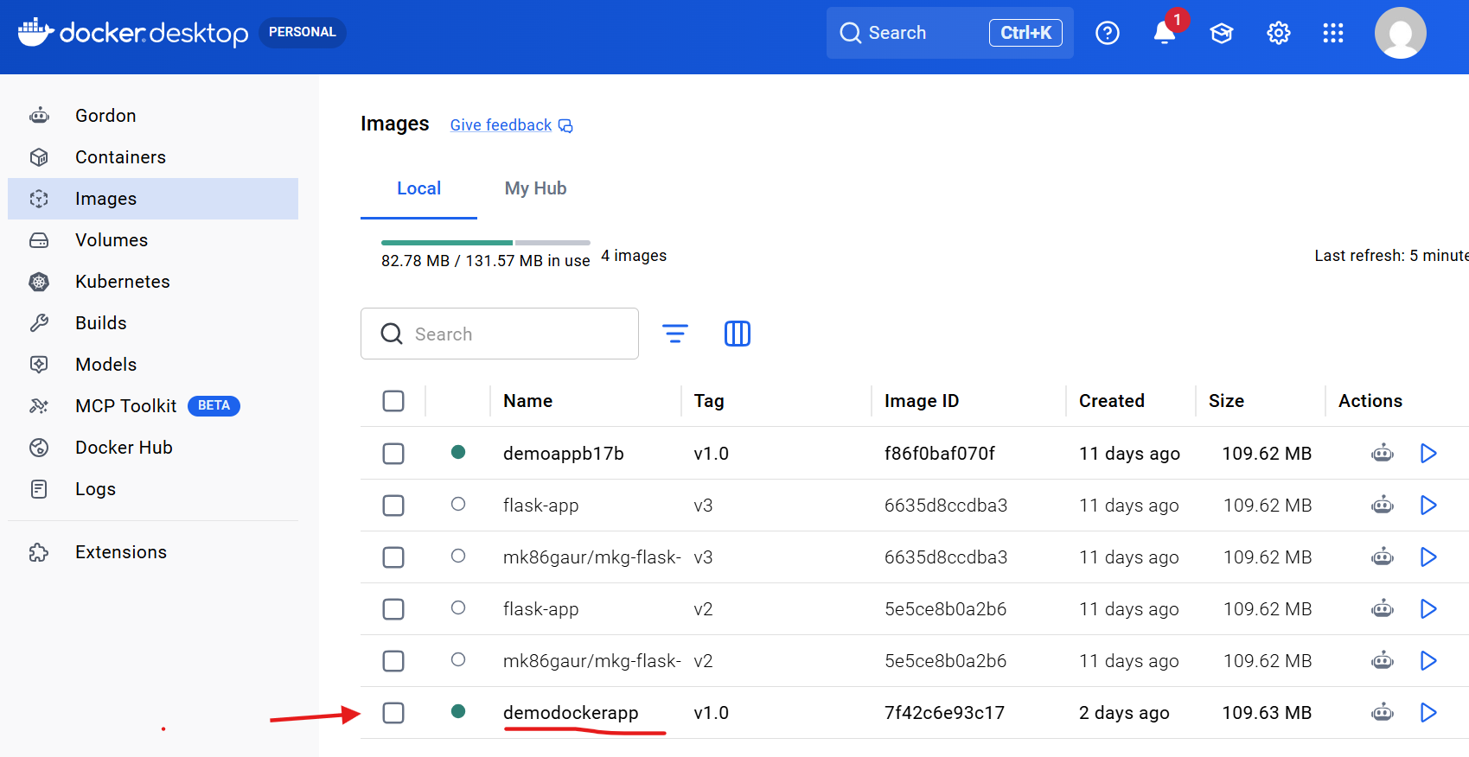
Local Docker desktop images
To make repository two way first through graphically and cli
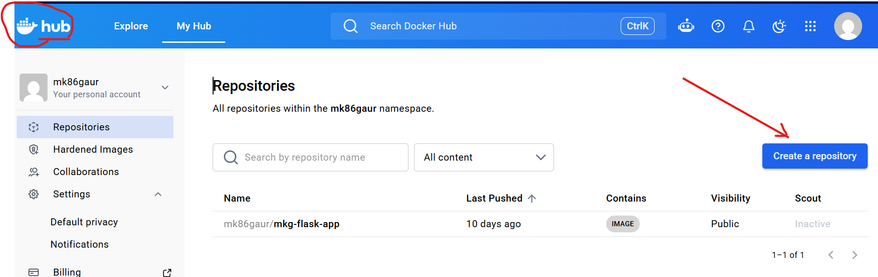

CLI
Check docker image is running
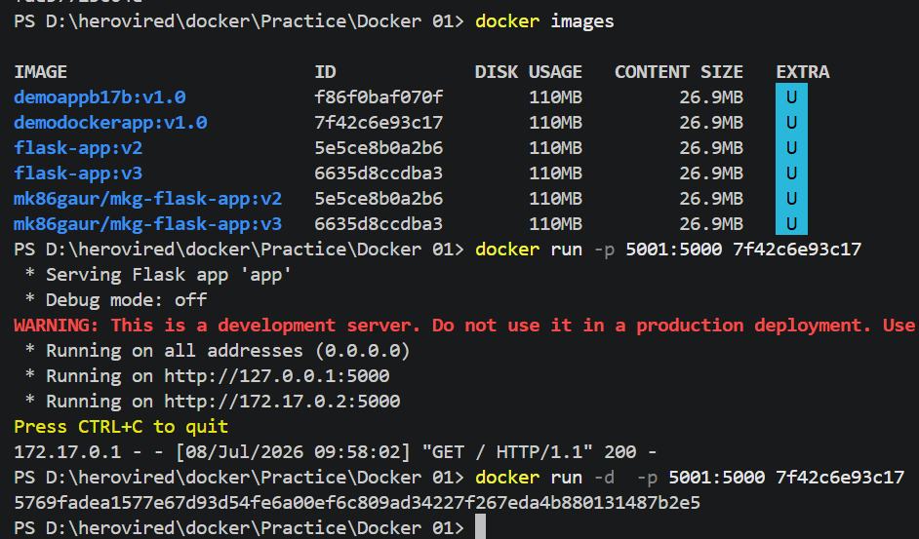
While using image id on port 5001
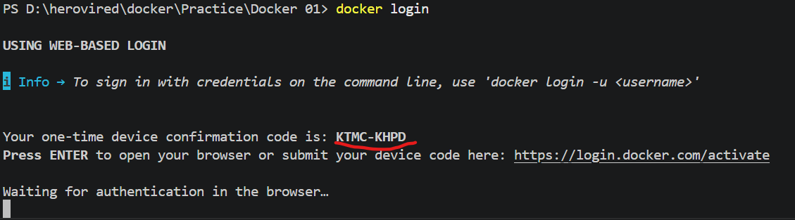
Copy the code and hit on link for authentication in the browser.

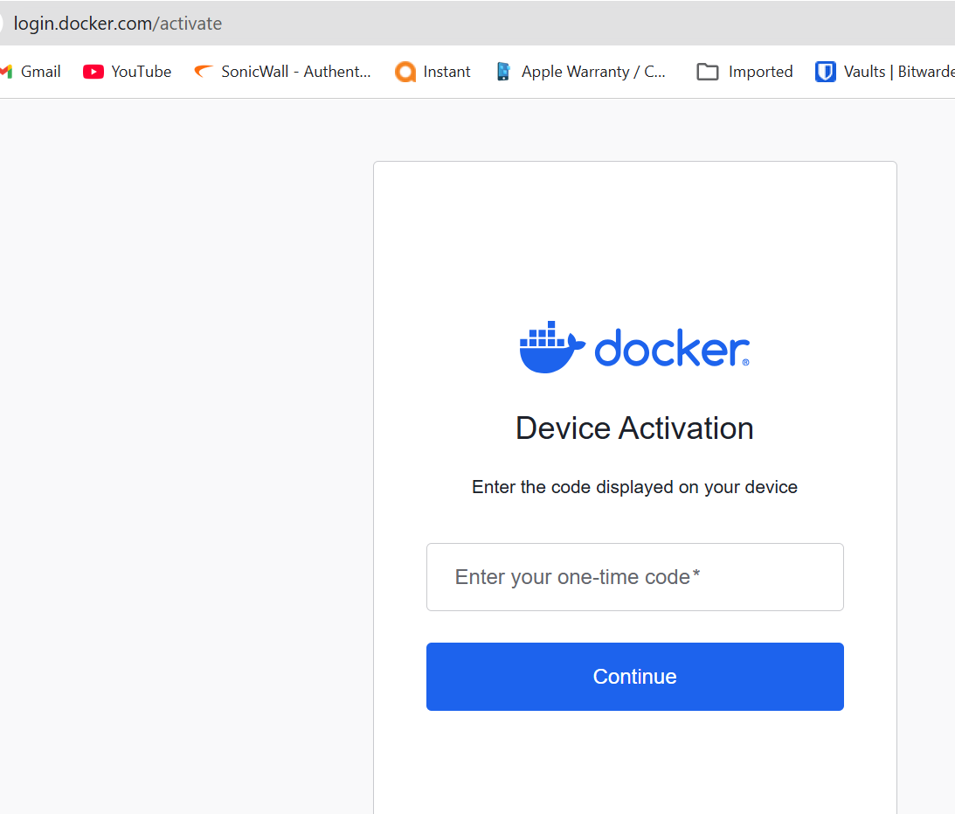
After login
Make image to docker hub format – which image – whos account – image and version
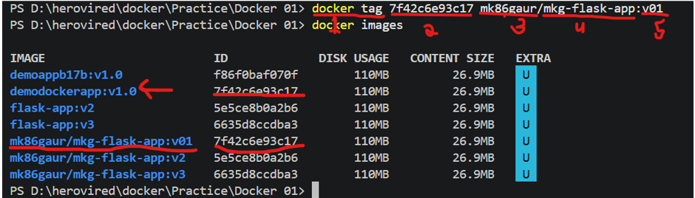
1= docker tage command
2= image name or image Id
3= docker account name
4= repository name
5= version
For push repository on docker hup remotely using command docker push <repository name >
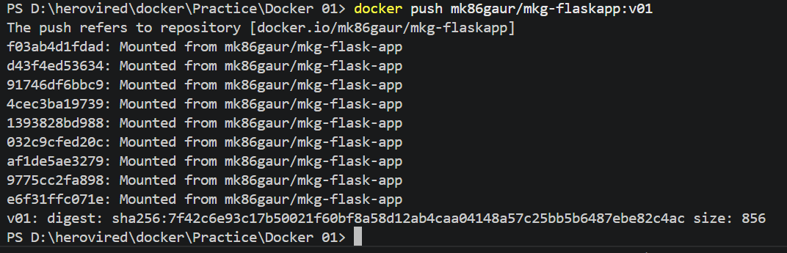
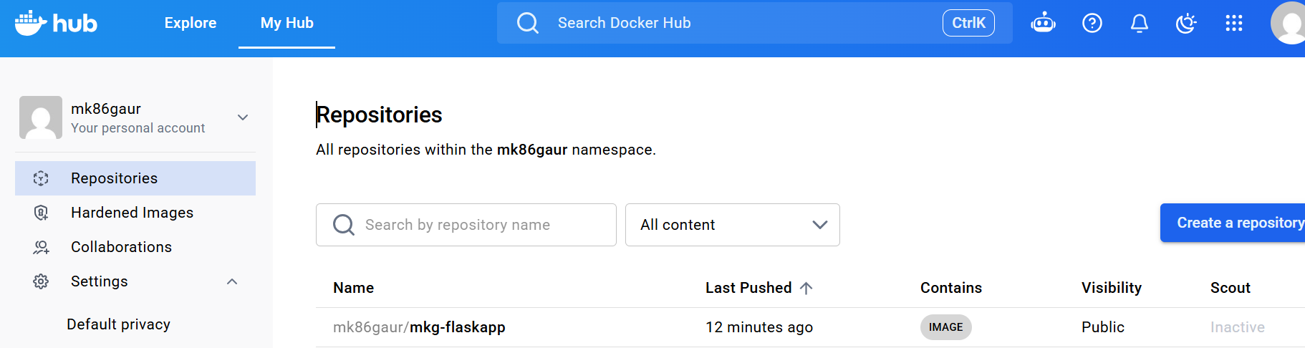
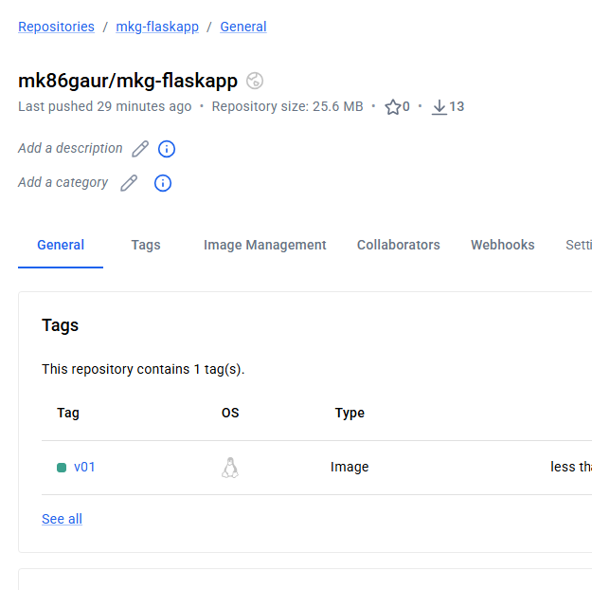
Les do push other version of images
docker bulid –t <images name with other version> . --------- ‘.’ Current directory path
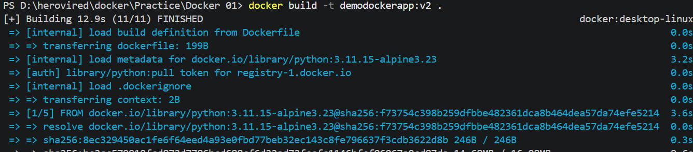
Tag with version(v02) than push
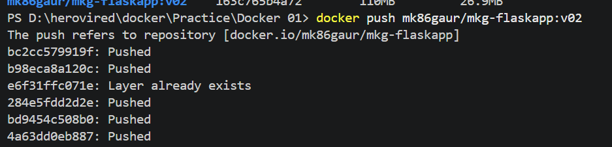
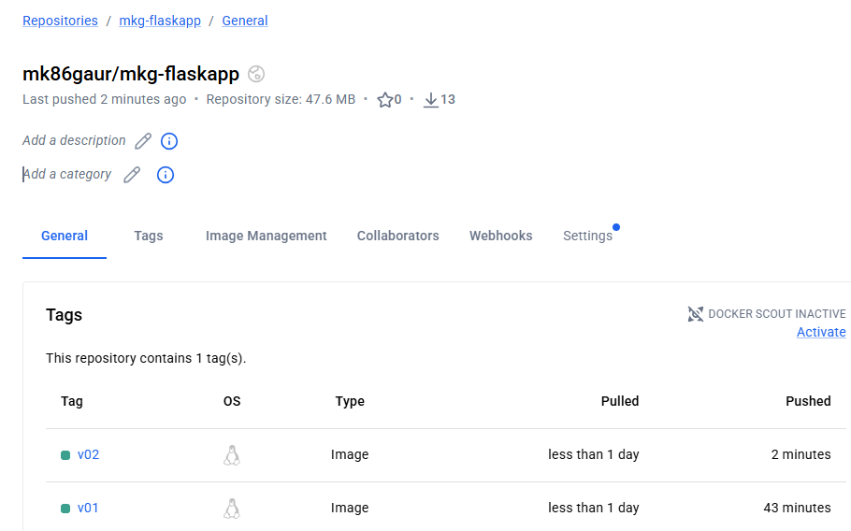
To remove docker image and recover
Command :- docker image rm <image name>
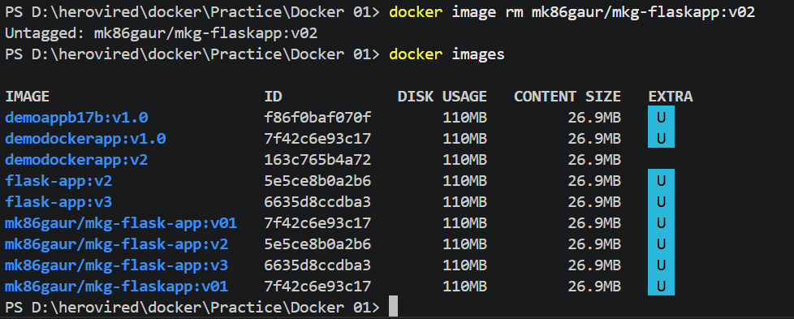
Command :- docker pull <image name or Id>
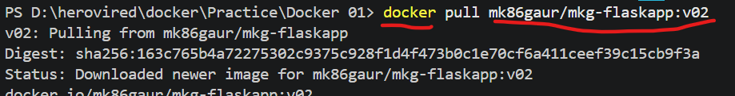
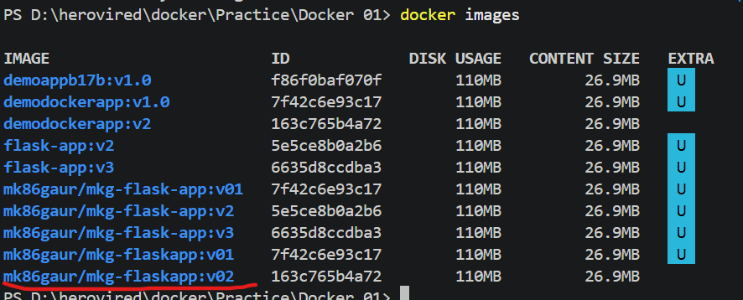
Revision to push 1- docker build 2- docker tag 3- docker push
- docker build –t <image name> .
- docker tag <image name > <docker-accoun-name/repository-name:version>
- docker push <name>
check previous repository
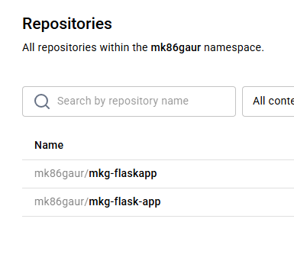
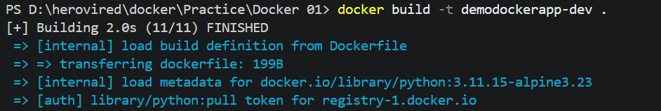
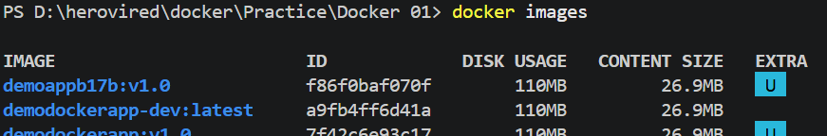
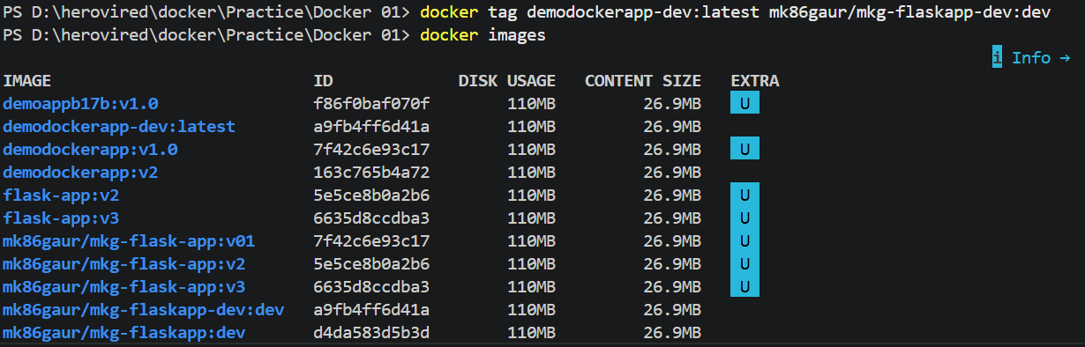
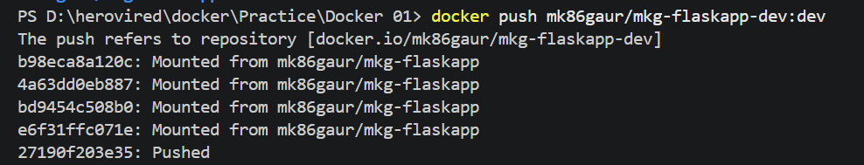
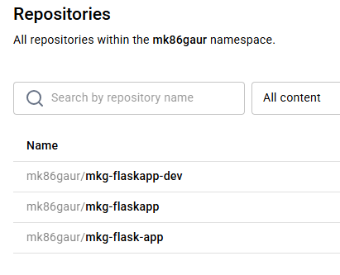git push
1= git status 2= git add . 3= git commit -m "Describe your changes" 4= git push

